Week-6
Q1: Explain the roles of the Driver, Cluster Manager, and Executor in a Spark application.
Ans.
Driver Node: The central master node that runs the main() program, creates the Spark Session, translates your code into a directed acyclic graph (DAG), and schedules tasks across executors.
Cluster Manager: The resource orchestrator (e.g., YARN, Kubernetes, or Spark Standalone) that manages cluster resources and allocates worker nodes to the Spark application.
Executors: Worker processes running on cluster nodes that execute the individual tasks assigned by the Driver, store data in memory or disk (caching), and return computation results back to the Driver.

Q2: How does Spark’s Lazy Evaluation strategy improve performance when chain-processing large datasets?
Ans.
Lazy Evaluation means Spark does not execute data transformations (like filter, select, or map) immediately when they are defined. Instead, it records them in a DAG (Lineage Graph). Execution occurs only when an Action (like count(), show(), or write()) is invoked.
Performance Benefits:
Query Optimization: Spark’s Catalyst Optimizer examines the entire lineage graph at once to optimize execution plans (e.g., combining steps, eliminating unused columns, and reordering operations).
Reduced Memory & I/O Overhead: Spark avoids creating intermediate datasets in memory or on disk for every individual step.

Q3: Write a Spark command to read a CSV file located at "data/source.csv", ensuring the first row is treated as a header and inferSchema is enabled.
Ans.
df = (
spark.read.option("header", "true")
.option("inferSchema", "true")
.csv("data/source.csv")
)
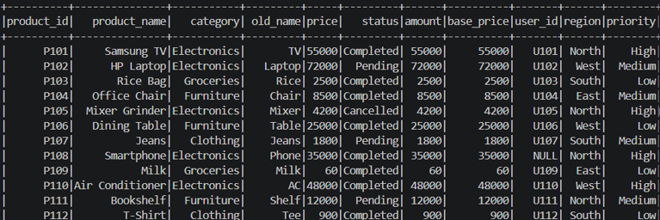
Q4: What is the difference between CSV and Parquet in terms of storage (row-based vs. columnar) and why does it matter for performance?
Ans.
CSV (Row-Based / Plain Text): Stores data line-by-line across all columns. To read even a single column, Spark must scan the entire file from start to finish.
Parquet (Columnar / Binary): Stores data organized by columns rather than rows, with built-in compression and metadata (like column min/max values).
It matters for performance:
- Column Pruning: If a query only needs 2 out of 50 columns, Parquet reads only those 2 columns off disk, skipping 96% of the data.
- Efficient Compression: Columnar storage places similar data types together, enabling high compression ratios and reducing I/O.

Q5: Given a DataFrame df, write a query to select the columns product_id and price where the category is 'Electronics'.
Ans.
from pyspark.sql.functions import col
result_df = df.filter(col("category") == "Electronics").select(
"product_id", "price"
)
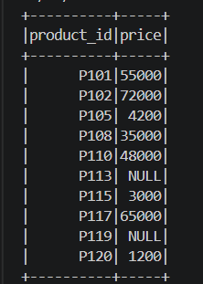
Q6: Write the code to "revise" a DataFrame by renaming the column old_name to new_name and casting the price column from a String to a Double.
Ans.
from pyspark.sql.functions import col
revised_df = df.withColumnRenamed("old_name", "new_name").withColumn(
"price", col("price").cast("double")
)
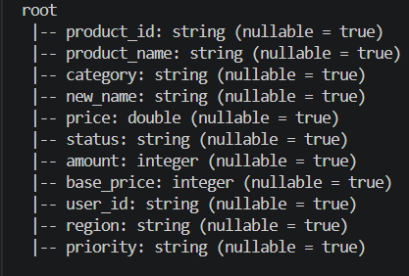

Q7: How does Spark use the Lineage Graph (DAG) to provide fault tolerance if a worker node fails?
Ans.
Spark use the Lineage Graph (DAG) to provide fault tolerance if a worker node fails because Data Frames and RDDs in Spark are immutable, Spark keeps track of every transformation applied to the raw data in a DAG (Lineage Graph).
If a worker node crashes and loses an in-memory partition, Spark does not need to restart the entire job or rely on data replication. Instead, it inspects the lineage graph and recomputes only the lost partition from the original source data using another available worker.

Q8: Write a query to filter a DataFrame df_orders for rows where the status is 'Completed' AND the amount is greater than 1000.
Ans.
from pyspark.sql.functions import col
filtered_orders = df_orders.filter(
(col("status") == "Completed") & (col("amount") > 1000))
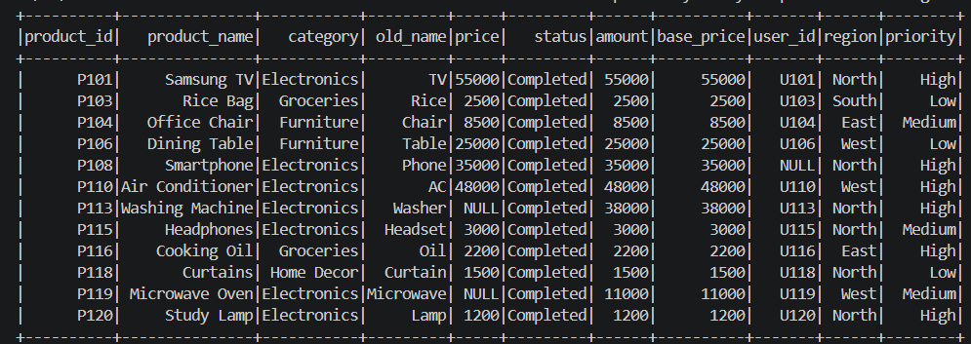

Q9: Explain the concept of Predicate Pushdown in Parquet and how it affects the amount of data loaded into memory.
Ans.
Predicate Pushdown is an optimization technique where filter conditions (predicates like WHERE status = 'Completed') are pushed down to the storage layer (file format) before data is read into memory.
Since Parquet files contain metadata blocks storing min/max values for data chunks, Spark reads the metadata first. If a chunk’s min/max shows that no row matches the filter, Spark skips reading that entire block of data from disk into memory, drastically cutting down I/O and RAM consumption.

Q10: Write a code snippet to add a new column final_price which is the base_price multiplied by 1.18 (18% tax).
Ans.
from pyspark.sql.functions import col
df_with_tax = df.withColumn("final_price", col("base_price") * 1.18)

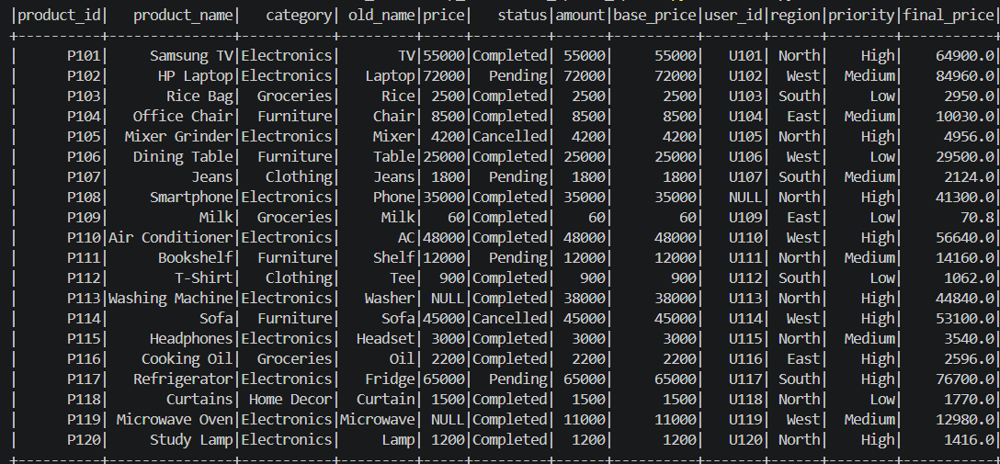

Q11: What is the difference between Transformations and Actions? Provide two examples of each.
Ans.
Transformations:
Transformations are operations that create a new DataFrame or RDD without immediately executing the computation. Spark records these operations and executes them only when an action is called.
Lazy (recorded in DAG, not evaluated immediately).
Examples of Transformations: filter(), select(), groupBy(), withColumn()

Actions:
Actions are operations that trigger the execution of all pending transformations and produce a result or output.
Eager (triggers job execution across the cluster).
Examples of Actions: count(), collect(), show(), write.parquet()

Q12: Write the Spark command to load a Parquet file from "path/to/input", filter out any rows where user_id is null, and save the result as a CSV at "path/to/output".
Ans.
df_parquet = spark.read.parquet("path/to/input")
df_filtered = df_parquet.filter(df_parquet["user_id"].isNotNull())
df_filtered.write.mode("overwrite").option("header", "true").csv("path/to/output")
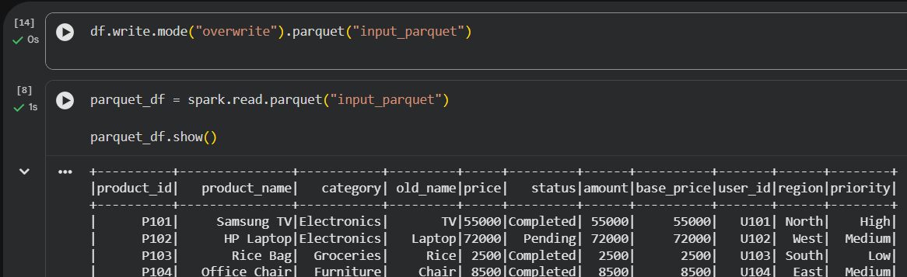

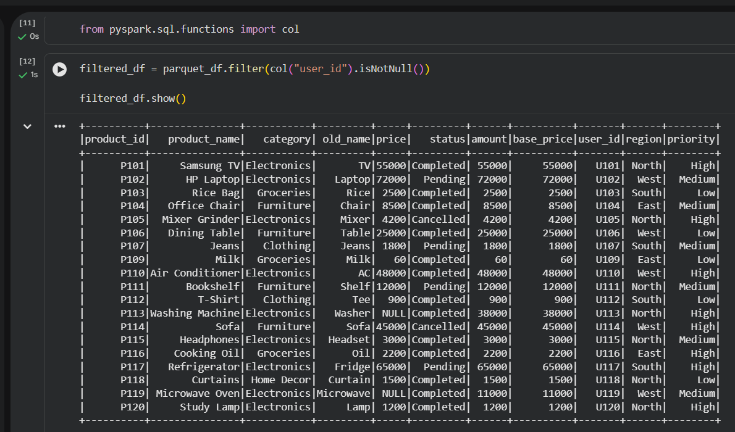

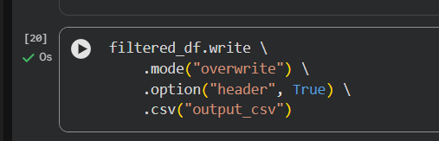

Q13: In Spark Architecture, what is the difference between Client Mode and Cluster Mode?
Ans.
Client Mode: The Driver process runs directly on the client machine (e.g., your local computer or edge node) that submitted the job. If the client machine closes or loses connection, the application terminates. Best for interactive debugging and development.
Cluster Mode: The Driver process is spawned inside one of the worker nodes within the cluster by the Cluster Manager. The client machine can disconnect after job submission, and the application will continue running safely on the cluster. Best for production deployments.

Q14: Write a query to filter a dataset for rows where the region is 'North' OR the priority is 'High'.
Ans.
from pyspark.sql.functions import col
filtered_df = df.filter((col("region") == "North") | (col("priority") == "High"))

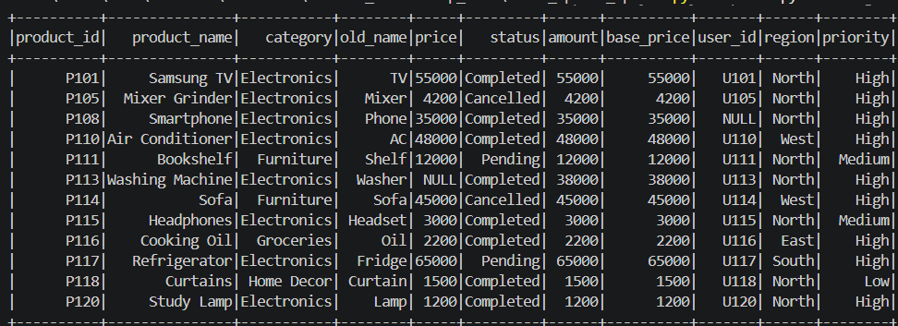

Q15: When exploring a dataset, why is it safer to use .show(5) instead of .collect() on a multi-terabyte dataset?
Ans.
It is safer to use .show(5) instead of .collect() on a multi-terabyte dataset because of the following reasons:
.show(5): Fetches and displays only 5 rows from the cluster workers to the driver terminal. It uses minimal network bandwidth and memory.
.collect(): Attempts to retrieve every single row across all partitions in the multi-terabyte dataset and pull them all into the Driver process memory. On large datasets, this almost instantly causes an OutOfMemoryError (OOM) and crashes the Driver application.

